Figure 1- Sequence Diagram- User Registration

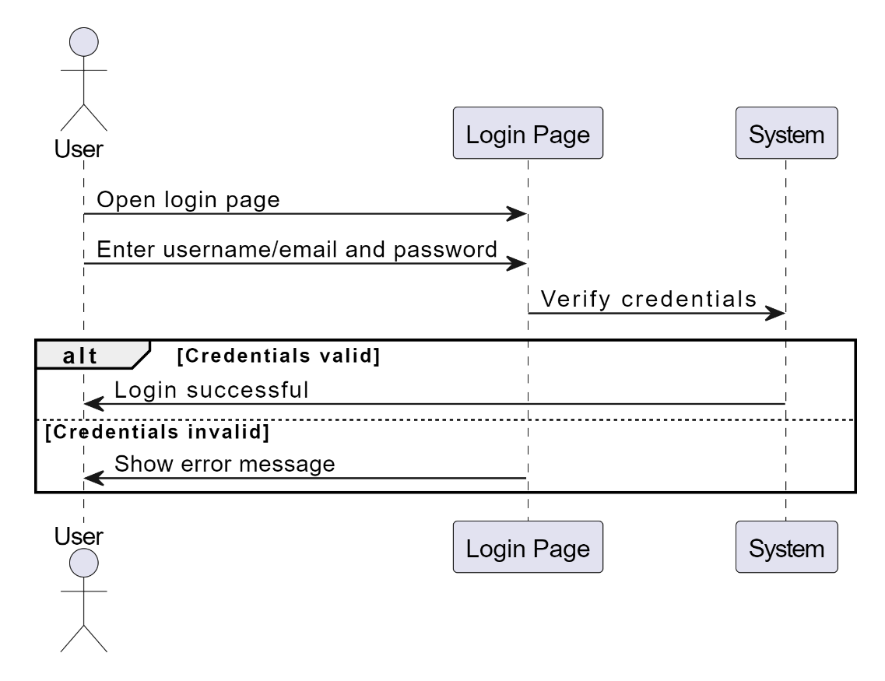

Figure 2- Sequence Diagram- User Login

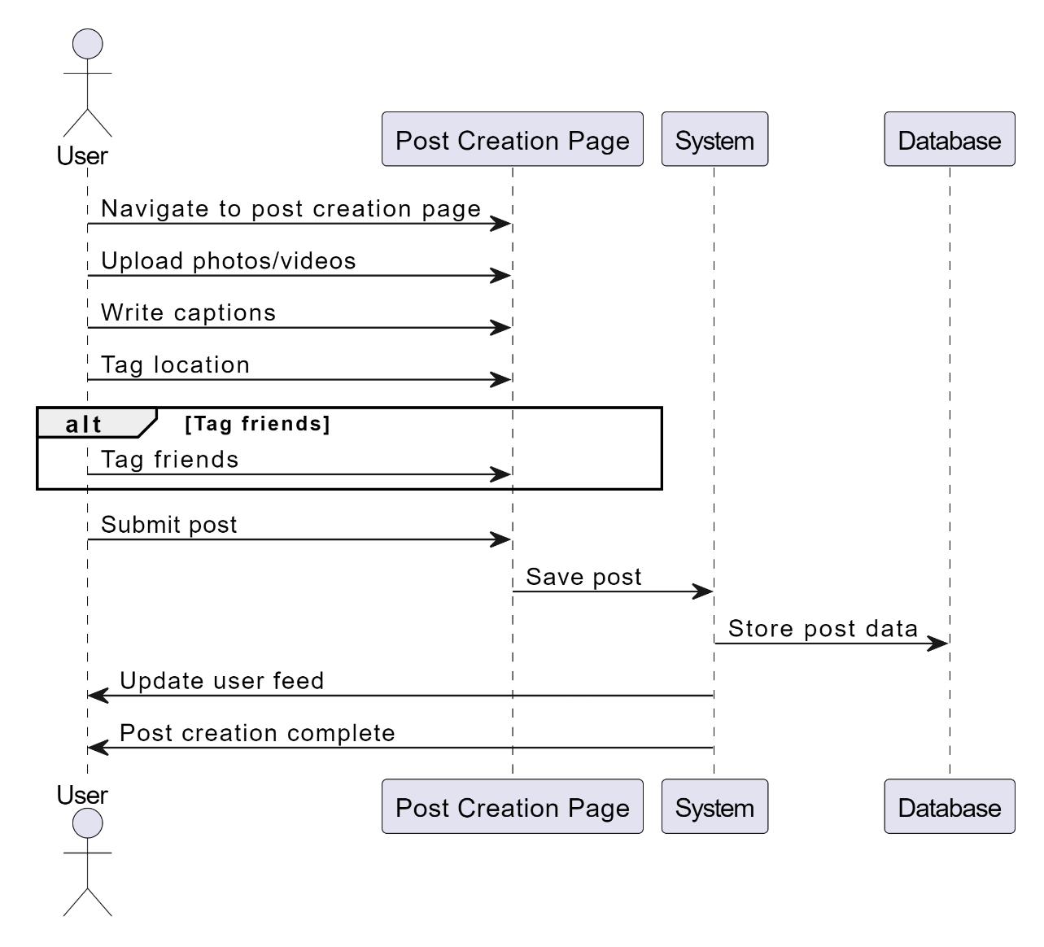

Figure 3- Sequence Diagram- Posting a travel experience

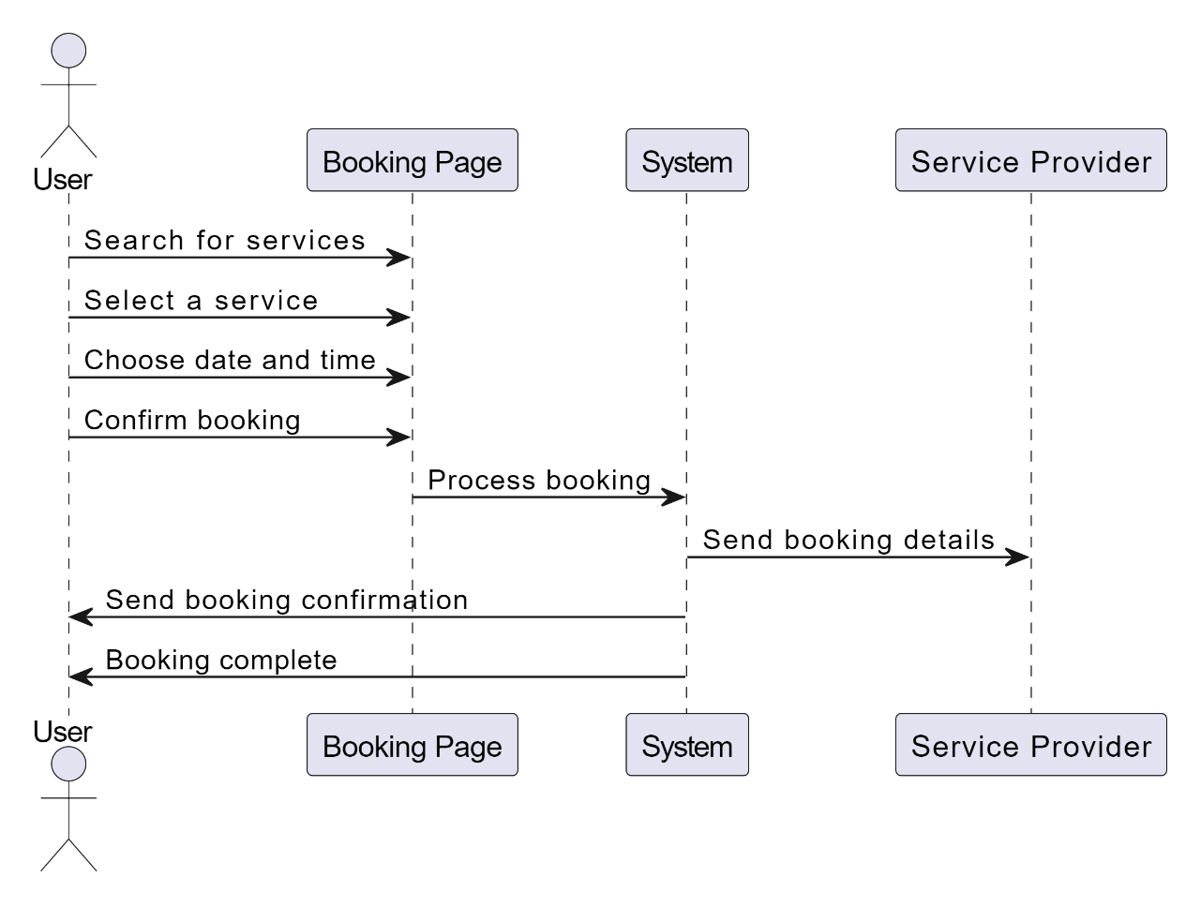

Figure 4- Sequence Diagram- Booking a Service

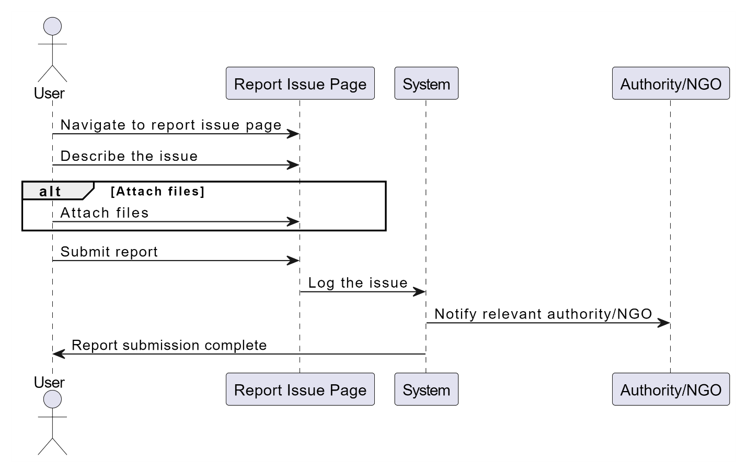

Figure 5- Sequence Diagram- Report an Issue

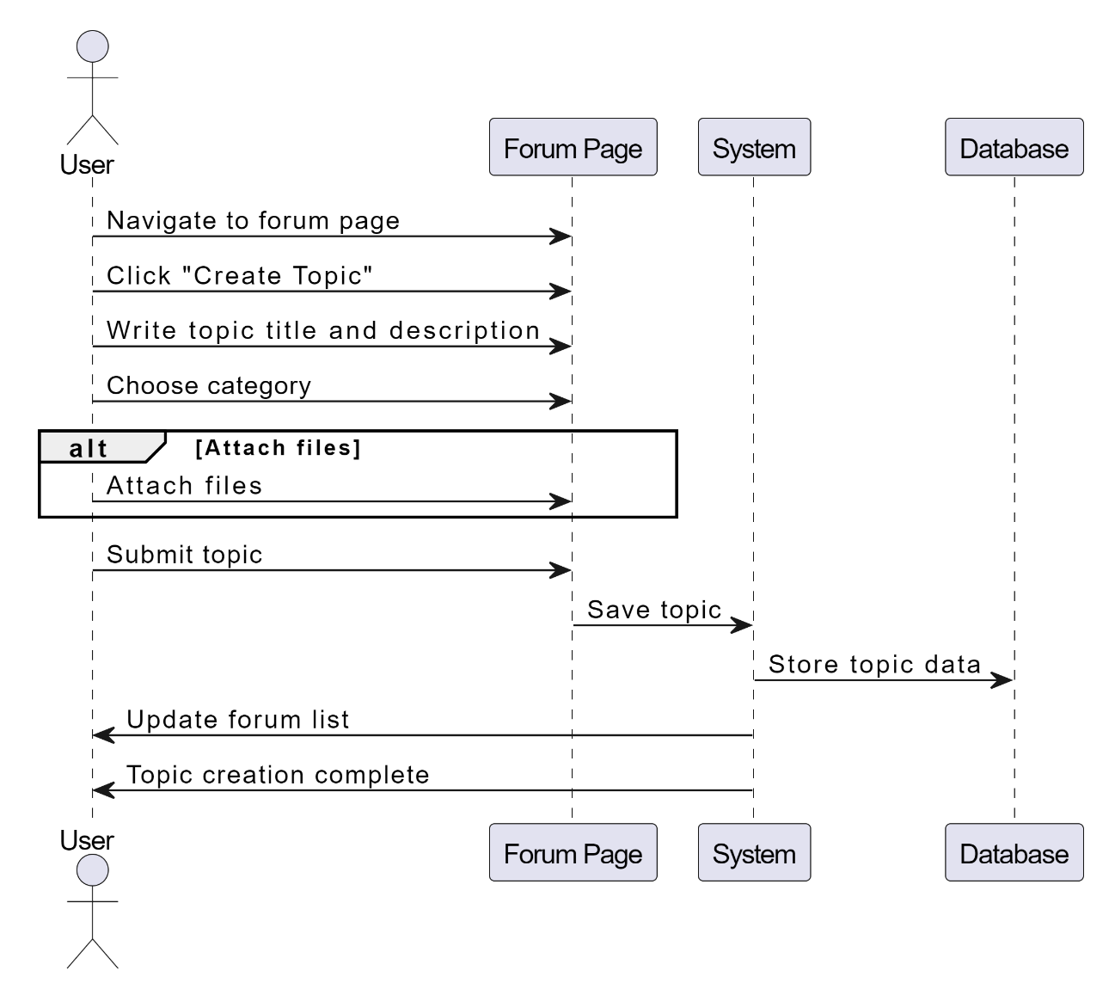

Figure 6- Sequence Diagram- Create a forum topic